This year, 2016, marks the 50th anniversary of the National Historic Preservation Act, which created a national historic preservation agenda and specific roles for the federal government, the states, and eventually local governments in promoting the preservation of historic buildings and archaeological sites. The Utah State Historic Preservation Office (SHPO) has been very active since that time, and it began aggressively promoting the Certified Local Government (CLG) after its creation in the mid-1980s, committed to the importance of involving cities and counties in the historic preservation arena. Utah has been a leader in the CLG field, bringing in more than 90 local government partners. This local-government emphasis laid the groundwork for regional efforts that envisioned broader, regional preservation of not just buildings but entire communities, their economies, and lifeways. The Mormon Pioneer National Heritage Area is the offspring of that expansive, multi-year effort.

Sanpete County:
No other county in Utah can match Sanpete County for its coordinated historic preservation efforts over the last 20+ years. Individual communities in the county have been pursuing their own preservation agendas since the 1970s, and many of them became “partners in preservation” with the State Historic Preservation Office (SHPO) and the National Park Service by become Certified Local Governments (CLGs) in the 1980s and ‘90s. CLG grants from the SHPO helped support many individual preservation projects, but the creation of the Sanpete Heritage Council in the mid-1990s brought communities throughout the county together to develop broader goals and coordinate projects to maximize their effectiveness. This Council evolved into the Utah Heritage Highway 89 Alliance, which is now the coordinating body for the Mormon Pioneer National Heritage Area. Preservation projects of note include the following

- Mt. Pleasant: The downtown commercial district was listed in the National Register in 1979, and the city became a Main Street community in 1994 to further promote downtown revitalization. The city also created a “historic overlay zone” in 1999, which has been instrumental in helping preserve and encourage the rehabilitation of historically significant buildings.

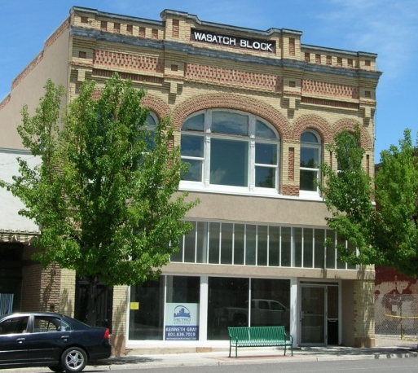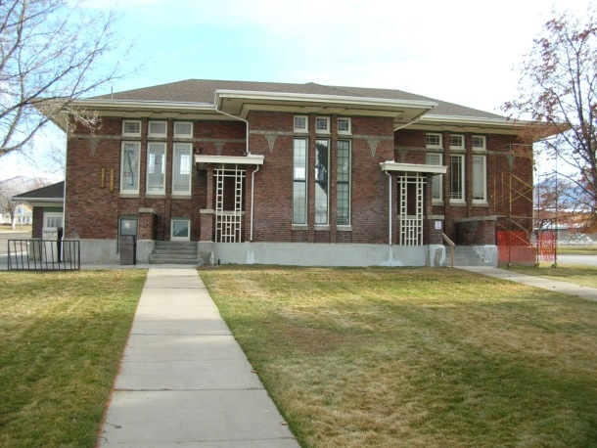

- Spring City: The entire town was listed as a National Register historic district in 1978, and the community has been active in trying to preserved its “best preserved Mormon village” status ever since. Since 1981, local volunteers have conducted an annual historic homes tour to raise funds to preserve the landmark 1899 school building. After raising more than $750,000 through home tour proceeds and grants, the building is nearing completion to serve as the city hall.

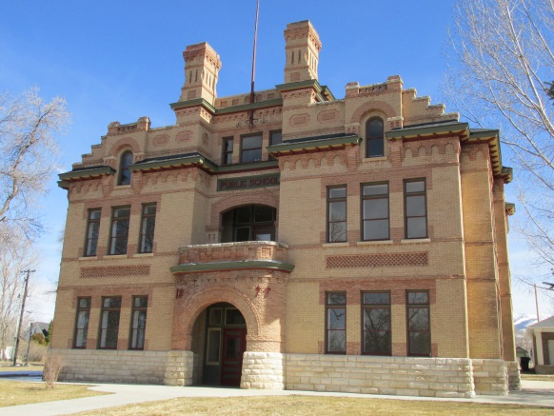

- Ephraim: Local residents saved the 1872 Ephraim Co-op from the wrecking ball in 1969, but it wasn’t until 20 years later that they secured funding to rehab the building. A craft co-op operated on the main floor, and the second floor served as reception/meeting space. The adjacent granary was rehabbed as an art center/gallery in 1991.
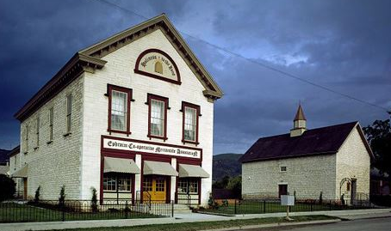

- Gunnison: The 1912 Casino Star Theatre is the architectural star on Gunnison’s Main Street, but it languished in disrepair for decades before a local group took it on as a project in the mid-2000s. The restored theatre has been a catalyst for downtown revitalization. It inspired the city to create a façade rehab program that has benefitted 25 other downtown buildings and spurred a dramatic increase in restaurant and retail sales.
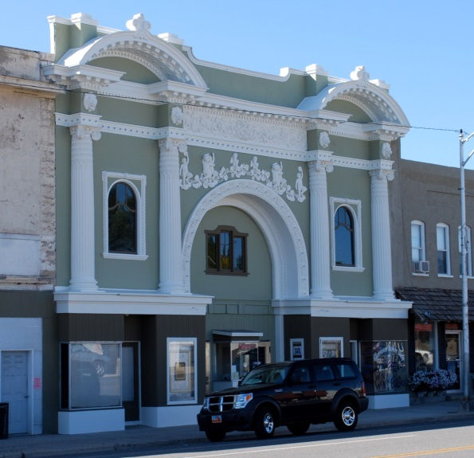

Sevier County:
Standout historic preservation projects in the county include the Salina Presbyterian Church (now Miss Mary’s Museum), and Carnegie library rehab projects in Salina and Richfield. The former church, now a museum, is a cultural landmark in the city. It has been the recipient of considerable local investment of cash and labor, supplemented by grants from the SHPO for a variety of structural and cosmetic improvements, including repairs to the steeple/bell tower from damage caused by a lightning strike.

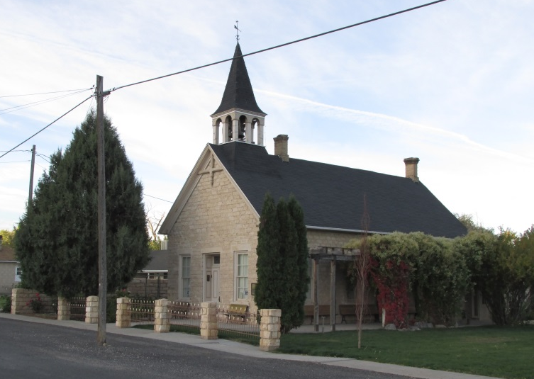

Piute County:
The Piute County Courthouse in Junction is the most prominent building in the county and the most visible rehabilitation project. The building was extensively damaged by a fire in 2002. It was vacant at the time, the county having moved its offices to a new building at the north end of town.

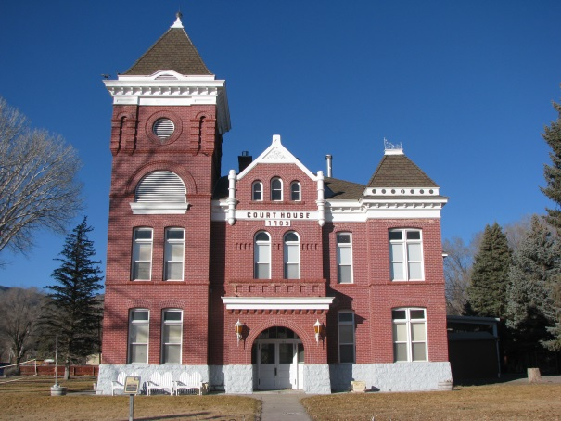

Another significant historic preservation project in the county was the refurbishing of the old Pines Hotel in Marysvale in the mid-1990s. The building, claimed by some to be the oldest operating hotel in Utah, had fallen into disrepair over the years and needed extensive work. The owners sought advice from a preservation architect and additional input from the SHPO as they brought the building back to life. Though the hotel originally served travelers along what is now Historic Highway 89, many of today’s guests are ATV riders following the popular, long-distance Piute ATV trail that passes through the area.

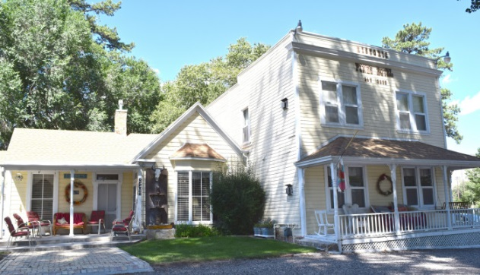

Garfield County
Downtown Panguitch, the historic commercial core of the county dating from the late 1890s and early 1900s, experienced a revival in the 1990s and 2000s. The community’s participation in the state’s Main Street program helped focus attention and resources on the buildings and businesses, and spurred the creation of a downtown master plan. Events, such as the unique and very popular Quilt Walk, have brought additional visibility—and lots of visitors—to the community. Restored buildings, an inviting streetscape, and new and revitalized businesses are now part of downtown Panguitch’s allure.

Wayne County
The 1898 Log Meetinghouse in Torrey is a Main Street landmark in this gateway community to Capitol Reef National Park. The building was vacant and in disrepair until local citizens decided to step in and rescue it. Working with the SHPO, they were able to get the building listed in the National Register of Historic Places in 1993, which enabled them to receive grants to help with the restoration.

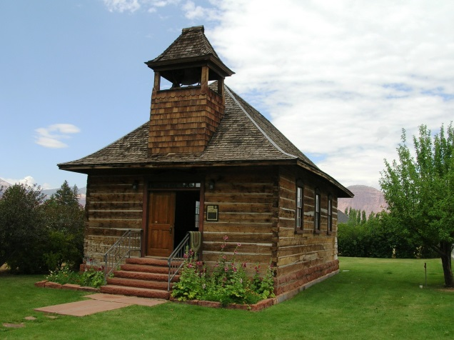

Kane County
Since 1974, the town of Kanab has owned and operated the “Heritage House” museum in the 1896 Bowman/Chamberlain House, one of Utah’s best examples of the Queen Anne style. Local volunteers did most of the restoration work, aided in part by a small Bicentennial grant and supplemental grants over the years from the SHPO. The rehabilitation of this house was remarkably enlightened for its time, emphasizing modest repairs and the retention of original craftsmanship over a more aggressive and romanticized remodeling.

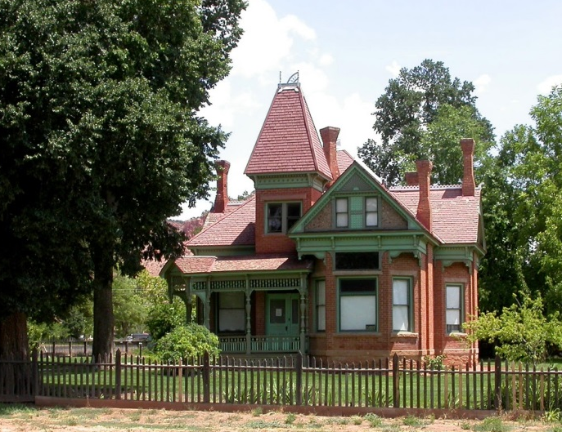

The city has also invested in the restoration of its 1939 Carnegie Library, a distinctive blend of Prairie School and Art Deco styling. The local historic preservation commission spearheading the listing of the library in the National Register in 1995, then obtained several grants from the SHPO to aid the restoration effort.
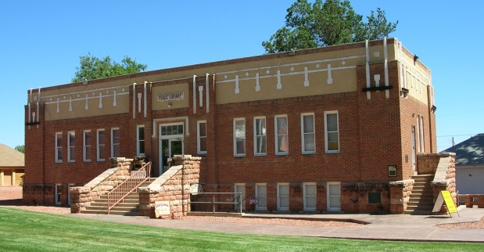

Another landmark preservation project in Kane County has been the revitalization of the home and studio of nationally renowned artist Maynard Dixon, located along Highway 89 near Mt. Carmel. The arts and historic preservation have been successful partners in many communities, but this property is a unique blossoming of that symbiosis. With assistance from the SHPO, the property was listed in the National Register in 2002. The history and authenticity of the complex has drawn thousands for painting competitions and celebrations, building on Maynard Dixon’s vision of the region as a place of artistic inspiration.
